Project 1

Title

The Land of Osirius (Version 1.0.0)

Adventure RPG game

Course

CSC-17A

Section

48130

Due Date

October 26, 2014

Author

Hamza Khan

**Table of Contents**

1. Introduction………………………………………………………………………………………3
2. Game play and Rules…………………………………………………………………………..3
3. Development Summary………………………………………………………………………...3
4. Description……………………………………………………………………………………….3
   1. Flow Chart……………………………………………………………………………….4
   2. Concepts…………………………………………………………………………………4

4.2.a. Functions with Structures……………………………………………………...4

4.2.b. Memory Allocation……………………………………………………………..4

4.2.c. Array of Structures……………………………………………………………..4

4.3 Sample Input and Output……………………………………………………………….5

5. References………………………………………………………………………………………5

6. Program…………………………………………………………………………………………5

1. **Introduction**

One of the longest running RPG to date is the Final Fantasy franchise and the game that revitalized adventure games is the episodical video game made by Tell Tale Games, The Walking Dead. What would happen if Final Fantasy and The Walking Dead were to combine some of their ideas and philosophies? Here’s what would happen it would be one of the greatest games ever created. This is where the idea for my game came from. I wanted to have the amazing story that Tell Tale Games is known for and I wanted to have the amazing RPG mechanics that Final Fantasy is known for.

1. **Gameplay**

The gamplay for this game is pretty simple, because it’s a text based adventure RPG stylized game. The first chapter of this game is pretty dull because it’s introducing the player to the different mechanics that are in this game and also sets up the backstory of the mission their going on.

1. **Summary**

|  |  |
| --- | --- |
| Total number of actual code | 703 |
| Total amount of blank spaces | 127 |
|  |  |
| Total | 830 |

The reason why this game meets the requirements is that it contains more then 250 lines worth of code. Also my game contains mostly all of the concepts that you wanted in the program. In the program I have one set of array of structures, it also has a couple uses of pointer of structures, it also has one set of memory allocation. I tried to implement pointers with array’s but I had no clue how I was going to implement it because I believed that pointer are arrays. Some issues If faced in making the game work was that when I tried to get the memory allocation function to work it would always fail because I would forget to free the memory with would cause it to leak and when I realized where it was coming from it sent me for a loop because I forgot how to free it. Another issue I faced through the creation of the game was that some pointers failed to register or alter in the function or equation so I would have to leave them as regular integers. The last issue I faced with the creation of the game was that some functions just failed to work because it has some form of an invalid statement. To make this program work and fix it took me about eight days to make it function properly.

1. **Description**

4.1 Flow Chart

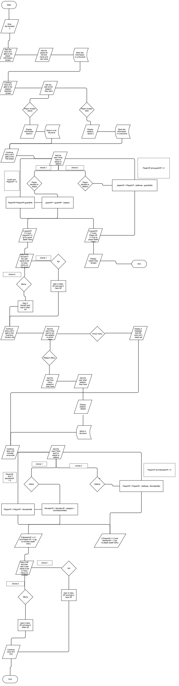

* 1. Concepts

4.2a Function with structures

In this program I used functions with structures about four to five times throughout the function. The first time I used it was setting up the weapon selection screen in lines 462 – 512. In those lines I use pointers to set values to certain parts of a structure to allow it to be accessed whenever I want it to. Then I call certain parts of that structure in the attack inventory screen.

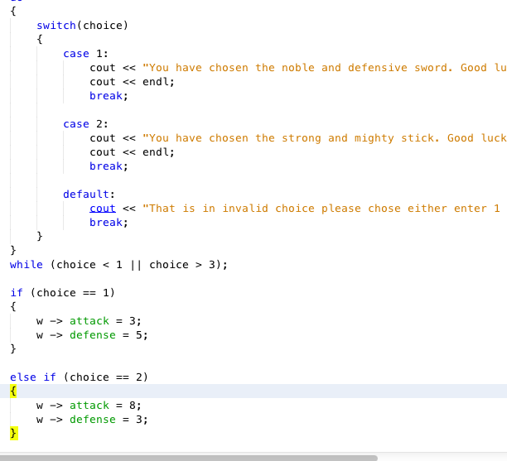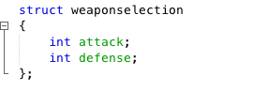

4.2b Memory Allocation

In this program I used Dynamic Memory Allocation to give a certain character more attack power based on the enemy they are facing, because this character is the greatest and strongest character in the game. I used this technique in lines 695 – 763 to allow the character to get stronger as the match progress. I plan to letter on in the game to weaken the character after a certain situation occurs.

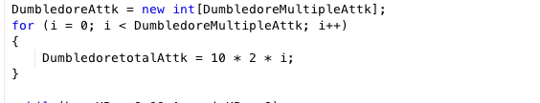

4.2c Array of Structures

In the program I used Array of Structures to determine how many items are in the inventory. This will allow the inventory to search for the item using the name of the item. I want to perfect in the future by allow the user to view the inventory whenever they want and also to allow to program to switch to different items on the fly. The array of structure concept was implemented in lines 661 – 679 to allow the inventory system to function.

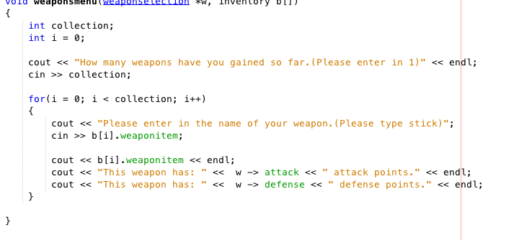

* 1. Sample input and output

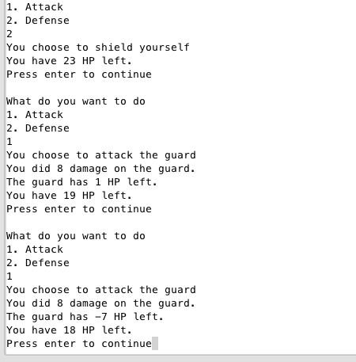

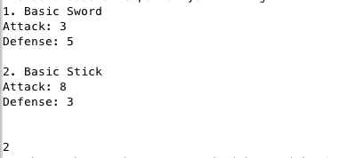

1. **References**

The entire code in my game is my own the only thing that isn’t mine is the system pause function because on my computer and all the other computer’s I tried to pause the program with system pause it would fail. So I had to google a way to find another way to allow the program to pause.

1. **Program**

#include <cstdlib>

#include <iomanip>

#include <iostream>

using namespace std;

//Declare structures

struct charactercreator

{

string firstname;

string lastname;

};

struct weaponselection

{

int attack;

int defense;

};

struct inventory

{

string weaponitem;

string armor; //Will get later on in the game

};

//Declare function prototypes

void Chapter1();

void weaponchoice(weaponselection *);

void guard(weaponselection *, int);

void Aracnia(weaponselection *, int *, int );

void weaponsmenu(weaponselection *, inventory[]);

void villianXP(int);

void heroXP(int);

int guarddeath(int, int &);

int AracniaDeath(int, int &);

int playerdeathbyguard(int, int &);

int playerdeathbyAracnia(int, int &);

int main()

{

// Declaring variables

int chapterSelection;

char cont = 'N';

cout << "The Land of Osirius" << endl << endl;

// Menu loop to select the problem

do

{

cout << "Please enter the number for the problem you want to run ";

cout << "or press '0' to exit" << endl;

cout << "1 = Chapter 1" << endl; //done

cout << "2 = Chapter 2 (coming soon)" << endl; //coming sometime in the future

cout << "3 = Chapter 3 (coming soon)" << endl; //coming sometime in the future

cout << "4 = Chapter 4 (coming soon)" << endl; //coming sometime in the future

cout << "5 = Chapter 5 (coming soon)" << endl; //coming sometime in the future

cin >> chapterSelection;

// Loop in case the user wants to run the same problem

do

{

switch (chapterSelection)

{

case 1:

Chapter1();

break;

case 2:

cout << "Coming soon" << endl;

break;

case 3:

cout << "Coming soon" << endl;

break;

case 4:

cout << "Coming soon" << endl;

break;

case 5:

cout << "Coming soon" << endl;

break;

default:

cout<<"That's an invalid entry\n";

break;

}

}

while(chapterSelection < 1 || chapterSelection > 6);

cout << "Do you want to run the ";

cout << "game again? ('Y' to ";

cout << "continue or any other key to ";

cout << "cancel)";

cin >> cont;

}

while(toupper(cont) == 'Y');

}

void Chapter1()

{

//Character profile in a structure

charactercreator creation;

weaponselection weapon;

const int items = 5;

inventory backpack[items];

//Declare local variables

string firstname;

string lastname;

int choice;

int baseHP = 30;

int maxHP = 120;

int DumbledoreHP;

int DumbledoreAttk;

//Set up the back story to the adventure

cout << "There was a legend a told by the native Americans saying that ";

cout << "every time you go to sleep at night your soul travels to ";

cout << "different worlds and that in the mornings it travels back to your ";

cout << "body, but if it doesn't get back to your body in time it is trapped ";

cout << "in that world until nightfall. Until your soul doesn't get back to ";

cout << "your body you are left in a coma and after three days you and your ";

cout << "soul start to die." << endl;

system("read -p \"Press enter to continue\" -n 1 -s");

cout << " " << endl << endl;

cout << "The Spirit's Arrival" << endl;

system("read -p \"Press enter to continue\" -n 1 -s");

cout << " " << endl << endl;

cout << "You: Night guys I'm gonna go to sleep." << endl;

system("read -p \"Press enter to continue\" -n 1 -s");

cout << " " << endl << endl;

//Opening scene

cout << "Tap. . . Tap. . . Tap" << endl;

cout << "Mysterious voice: Get up stranger or else you'll be in danger. ";

cout << "Get up now!"<< endl;

system("read -p \"Press enter to continue\" -n 1 -s");

cout << " " << endl << endl;

cout << "You: Ugh. Where am I and what's up with the bright light?" << endl;

system("read -p \"Press enter to continue\" -n 1 -s");

cout << " " << endl << endl;

cout << "Mysterious person: We need to hurry up or else you'll be captured. ";

cout << "Your our last hope of survival. Hurry up" << endl;

system("read -p \"Press enter to continue\" -n 1 -s");

cout << " " << endl << endl;

cout << "Both you and the mysterious person hide in a near by bush." << endl;

cout << "Then a horse with a rider on top of it came out of a bush with ";

cout << "10 guards following it." << endl;

system("read -p \"Press enter to continue\" -n 1 -s");

cout << " " << endl << endl;

cout << "Horse rider: Look around everywhere look under ever rock, bush, ";

cout << "cave and tree. If you have to burn this entire forest down, but ";

cout << "find the chosen one." << endl;

system("read -p \"Press enter to continue\" -n 1 -s");

cout << " " << endl << endl;

cout << "You get a closer look at the mysterious person who saved you and ";

cout << "reminds you of someone you know." << endl;

system("read -p \"Press enter to continue\" -n 1 -s");

cout << " " << endl << endl;

cout << "You: Hey are you by any chance Dumbuldore because you look a lot like him.";

system("read -p \"Press enter to continue\" -n 1 -s");

cout << " " << endl << endl;

//Get the players name

cout << "Mysterious person: Who the hell is Dumbledore, but forget about that. ";

cout << "I need to know your name to know whether to not to save you.";

cout << "What is your first name: ";

getline(cin,creation.firstname);

cout << "What is your last name: ";

getline(cin,creation.lastname);

cout << "Mysterious person: So your name is " << creation.firstname << " ";

cout << creation.lastname << endl;

system("read -p \"Press enter to continue\" -n 1 -s");

cout << " " << endl << endl;

cout << "Mysterious person: You are the one the prophecy talked about follow ";

cout << "me." << endl;

system("read -p \"Press enter to continue\" -n 1 -s");

cout << " " << endl << endl;

cout << "Guard: Looks like I just hit the jackpot capturing both the chosen ";

cout << "one and the rogue wizard Nucktuck" << endl;

system("read -p \"Press enter to continue\" -n 1 -s");

cout << " " << endl << endl;

cout << "Nucktuck: Well " << creation.firstname << " I must take your leave. ";

cout << "I leave you with a sword and a stick. Good Luck and find me if you ";

cout << "live. Every man for himself!" << endl;

system("read -p \"Press enter to continue\" -n 1 -s");

cout << " " << endl << endl;

//Goes to the menu to select a weapon

weaponchoice(&weapon);

cout << "Your weapon of choice is now in your inventory.";

cout << "(Inventory is still being made)" << endl;

system("read -p \"Press enter to continue\" -n 1 -s");

cout << " " << endl << endl;

//Guard taunt

cout << "Guard: So you can beat me with that weapon. I laugh at that ";

cout << "chosen one. Let's fight." << endl;

system("read -p \"Press enter to continue\" -n 1 -s");

cout << " " << endl << endl;

//Goes to the attack menu

guard(&weapon, baseHP);

cout << "You: Man I thought he would have given a better fight." << endl;

cout << "Mysterious figure: Hello stranger I saw what you did. I must say that was ";

cout << "quite impressive." << endl;

system("read -p \"Press enter to continue\" -n 1 -s");

cout << " " << endl << endl;

cout << "You: Uh no offense but who the hell are you." << endl;

system("read -p \"Press enter to continue\" -n 1 -s");

cout << " " << endl << endl;

cout << "Mysterious person: Oh sorry about that where our my manners. My name is ";

cout << "Dumbledore, one of the greatest wizards ever." << endl;

system("read -p \"Press enter to continue\" -n 1 -s");

cout << " " << endl << endl;

cout << "You: Wait your Dumbledore. OH MY GOD!" << endl;

system("read -p \"Press enter to continue\" -n 1 -s");

cout << " " << endl << endl;

cout << "Dumbledore: Yes I am one of the two last wizards that exist. The other ";

cout << "wizard is a man named Nucktuck, but unlike me who uses magic for good ";

cout << "he uses it for evil." << endl;

system("read -p \"Press enter to continue\" -n 1 -s");

cout << " " << endl << endl;

cout << "Distant guard: Hey guys I here voices close by lets head over there." << endl;

system("read -p \"Press enter to continue\" -n 1 -s");

cout << " " << endl << endl;

cout << "Dumbledore: Come with me stranger. We need to get you to safety." << endl;

system("read -p \"Press enter to continue\" -n 1 -s");

cout << " " << endl << endl;

cout << "Ten painful minutes later" << endl;

system("read -p \"Press enter to continue\" -n 1 -s");

cout << " " << endl << endl;

cout << "You: God that was a painfully long journey. Also, Dumbledore ";

cout << "I thought you said that it was going to be a breaze to get here." << endl;

system("read -p \"Press enter to continue\" -n 1 -s");

cout << " " << endl << endl;

cout << "Dumbledore: When did I say that? I don't remember saying that at all. ";

cout << "But forget about that. Welcome to my humble abode." << endl;

system("read -p \"Press enter to continue\" -n 1 -s");

cout << " " << endl << endl;

cout << "Dumbledore: So I introduced myself to you, but what is your name anyways." << endl;

system("read -p \"Press enter to continue\" -n 1 -s");

cout << " " << endl << endl;

cout << "You: Oh yeah I completely forgot. My name is " << creation.firstname << " ";

cout << creation.lastname << endl;

system("read -p \"Press enter to continue\" -n 1 -s");

cout << " " << endl << endl;

cout << "Dumbledore: Ah! Your the chosen one. You must be wondering why your here ";

cout << "right." << endl;

system("read -p \"Press enter to continue\" -n 1 -s");

cout << " " << endl << endl;

cout << "You: Yeah I do. Why was I brought here and also why were those";

cout << "guys looking for me." << endl;

system("read -p \"Press enter to continue\" -n 1 -s");

cout << " " << endl << endl;

cout << "Dumbledore: Well where can I start. I could tell you about the king or ";

cout << "I could tell you about the spirit wars. So I'll start from the beginning. " << endl;

system("read -p \"Press enter to continue\" -n 1 -s");

cout << " " << endl << endl;

cout << "Dumbledore: 10 years ago this land, Osirius was protected by the spirit lords Herana ";

cout << "and Namag. They would allow spirits like you to travel in and out of this land." << endl;

system("read -p \"Press enter to continue\" -n 1 -s");

cout << " " << endl << endl;

cout << "Dumbledore: Then one day a spirit named Boluck came into our land. At first he ";

cout << "helped the people and protected the spirits from harm. He would come to our land everday ";

cout << "and be gone before the portal closed. Then one day he brought three thousands ";

cout << "spirits into our land and ravaged it. The spirit lords didn't appreciate what Boluck ";

cout << "was doing to their land so they fought back with Boluck, but what they didn't ";

cout << "expect was that Boluck was expecting them and had thirty of the greatest wizards ";

cout << "set up a trap for the spirits to trap them. The spirits fell for the trap, but before ";

cout << "they were trapped they created a prophecy that 10 years from that point a spirit will ";

cout << "enter this land and defeat Boluck and free them from their prison. So Boluck became ";

cout << "The king of our land and keeping the citizens of our land under his";

cout << "control through fear."<< endl;

system("read -p \"Press enter to continue\" -n 1 -s");

cout << " " << endl << endl;

cout << "Dumbledore: So the spirit lords have been bidding their time and trying to gain back ";

cout << "their power. So today they let in the first spirit back into our land and you must ";

cout << "help and free the master spirits." << endl;

system("read -p \"Press enter to continue\" -n 1 -s");

cout << " " << endl << endl;

cout << "You: Man that sucks. I don't know if I could help, ";

cout << "but I'll try. So lets fight" << endl;

system("read -p \"Press enter to continue\" -n 1 -s");

cout << " " << endl << endl;

cout << "Dumbledore: Well lets go on a journey, but before we head out here's a backpack." << endl;

system("read -p \"Press enter to continue\" -n 1 -s");

cout << " " << endl << endl;

cout << "Welcome to the Inventory"<< endl;

cout << "1. Weapons" << endl;

cout << "2. Armor" << endl;

cout << "Please make a selection: ";

cin >> choice;

do

{

switch(choice)

{

case 1:

weaponsmenu(&weapon, backpack);

break;

case 2:

cout << "You don't have any armor yet." << endl;

break;

default:

cout << "That is an invalid choice please chose from 1-3" << endl;

break;

}

}

while(choice < 1 || choice > 3);

cout << "Dumbledore: Lets head out for our quest then." << endl;

system("read -p \"Press enter to continue\" -n 1 -s");

cout << " " << endl << endl;

cout << "Meanwhile in the castle of Boluck." << endl;

system("read -p \"Press enter to continue\" -n 1 -s");

cout << " " << endl << endl;

cout << "King Boluck: So Yami were you able to capture the spirit." << endl;

system("read -p \"Press enter to continue\" -n 1 -s");

cout << " " << endl << endl;

cout << "Yami: Well Your Highness we looked all over the spirit forest, but ";

cout << "we couldn't find him, but we did find this imposter guard in the forest ";

cout << "knocked out. He claims that he saw the chosen one and Nucktuck there." << endl;

system("read -p \"Press enter to continue\" -n 1 -s");

cout << " " << endl << endl;

cout << "King Boluck: You inbiciles! I gave you one job to capture the chosen one ";

cout << "but you couldn't even do that! Why the hell am keeping you as my guards. ";

cout << "Never mind that. How is the plan going is everything going as planned. ";

system("read -p \"Press enter to continue\" -n 1 -s");

cout << " " << endl << endl;

cout << "Yami: Everything is going as planned, but I must beg of you Your Highness ";

cout << "this plan of yours could end up killing you." << endl;

system("read -p \"Press enter to continue\" -n 1 -s");

cout << " " << endl << endl;

cout << "King Boluck: Not unless everything goes as I say." << endl;

system("read -p \"Press enter to continue\" -n 1 -s");

cout << " " << endl << endl;

cout << "Boluck walks into a room with a glass floor with the spirit lords trapped ";

cout << "underneath." << endl;

system("read -p \"Press enter to continue\" -n 1 -s");

cout << " " << endl << endl;

cout << "King Boluck: You know what Yami I think we should show the chosen one who ";

cout << "he's messing with. Release the giant spider." << endl;

system("read -p \"Press enter to continue\" -n 1 -s");

cout << " " << endl << endl;

cout << "Meanwhile back with our heroes" << endl;

system("read -p \"Press enter to continue\" -n 1 -s");

cout << " " << endl << endl;

cout << "You: It's been five hours and we haven't seen a single village. How ";

cout << "much further are we going to have to walk Dumbledore." << endl;

system("read -p \"Press enter to continue\" -n 1 -s");

cout << " " << endl << endl;

cout << "Dumbledore: It's just a little further I know it." << endl;

system("read -p \"Press enter to continue\" -n 1 -s");

cout << " " << endl << endl;

cout << "You: Dumbledore, you realize I've seen that rock about twenty times ";

cout << "already. I think we're lost." << endl;

system("read -p \"Press enter to continue\" -n 1 -s");

cout << " " << endl << endl;

cout << "Dumbledore: Nonsense I know this land like it's on the back of my hand. ";

cout << "Now I think we have to go east and we'll be there." << endl;

system("read -p \"Press enter to continue\" -n 1 -s");

cout << " " << endl << endl;

cout << "You: Do you think that it's that way or you know for sure it's that way ";

cout << "because there is a huge difference from knowing and believing." << endl;

system("read -p \"Press enter to continue\" -n 1 -s");

cout << " " << endl << endl;

cout << "Dumbledore: I know it's this way boy! Now follow me, my feet are killing me ";

cout << "so hurry along." << endl;

system("read -p \"Press enter to continue\" -n 1 -s");

cout << " " << endl << endl;

cout << "Dumbledore: Stop where you are boy and get ready for an attack.";

system("read -p \"Press enter to continue\" -n 1 -s");

cout << " " << endl << endl;

cout << "Raspy voice: So Dumbledore you found the chosen one I see. Now hand him ";

cout << "over to me so that I can claim my reward from Boluck" << endl;

system("read -p \"Press enter to continue\" -n 1 -s");

cout << " " << endl << endl;

cout << "Dumbledore: Never Aracnia! The boy stays with me." << endl;

system("read -p \"Press enter to continue\" -n 1 -s");

cout << " " << endl << endl;

cout << "Aracnia: Well then I'll just take him by force after killing you." << endl;

system("read -p \"Press enter to continue\" -n 1 -s");

cout << " " << endl << endl;

Aracnia(&weapon, &DumbledoreAttk, baseHP);

cout << "Dumbledore: I think we should rest now. Good night chosen one." << endl;

cout << "End of Chapter 1. Chapter 2 will be available soon." << endl;

}

void weaponchoice(weaponselection *w)

{

//Declare local variable

int choice;

//Starter weapons

cout << "Please choose a weapon of your liking" << endl;

cout << "1. Basic Sword" << endl;

cout << "Attack: 3" << endl;

cout << "Defense: 5" << endl << endl;

cout << "2. Basic Stick" << endl;

cout << "Attack: 8" << endl;

cout << "Defense: 3" << endl << endl;

cin >> choice;

do

{

switch(choice)

{

case 1:

cout << "You have chosen the noble and defensive sword. Good luck.";

cout << endl;

break;

case 2:

cout << "You have chosen the strong and mighty stick. Good luck.";

cout << endl;

break;

default:

cout << "That is in invalid choice please chose either enter 1 or 2";

break;

}

}

while (choice < 1 || choice > 3);

if (choice == 1)

{

w -> attack = 3;

w -> defense = 5;

}

else if (choice == 2)

{

w -> attack = 8;

w -> defense = 3;

}

}

void guard (weaponselection *w, int baseHP)

{

//Declare local variables

int guardAttk;

int guardHP = 25;

int choice;

while(baseHP > 0 && guardHP > 0)

{

//Get the attack points of the guard

guardAttk = (rand()%5)+1;

cout << "What do you want to do" << endl;

cout << "1. Attack" << endl;

cout << "2. Defense" << endl;

cin >> choice;

do

{

switch(choice)

{

case 1:

cout << "You choose to attack the guard" << endl;

break;

case 2:

cout << "You choose to shield yourself" << endl;

break;

default:

cout << "That is in invalid choice please chose either enter 1 or 2";

break;

}

}

while(choice < 1 || choice > 3);

if (choice == 1)

{

//Display damage done and life left on the guard

guardHP = guardHP - (w -> attack);

cout << "You did " << w -> attack << " damage on the guard." << endl;

cout << "The guard has " << guardHP << " HP left." << endl;

//Display your life left after guard attacks

baseHP = baseHP - guardAttk;

cout << "You have " << baseHP << " HP left." << endl;

system("read -p \"Press enter to continue\" -n 1 -s");

cout << " " << endl << endl;

}

else if (choice == 2)

{

baseHP = baseHP-((w -> defense) - guardAttk);

cout << "You have " << baseHP << " HP left." << endl;

system("read -p \"Press enter to continue\" -n 1 -s");

cout << " " << endl << endl;

}

guarddeath(guardHP, baseHP);

playerdeathbyguard(guardHP, baseHP);

}

}

int playerdeathbyguard(int guardHP, int &baseHP)

{

if (guardHP > 0 && baseHP <= 0)

{

cout << "Guard: So you thought you could beat me huh. ";

cout << "You couldn't even destroy me. HaHaHa" << endl;

cout << "Game Over" << endl;

}

return 0;

}

int guarddeath(int guardHP, int &baseHP)

{

//Declare local variables

int choice;

int antagonist;

int protagonist;

int XP;

if (guardHP <= 0 && baseHP > 0)

{

cout << "The guard has fallen" << endl;

cout << "You have two options you can choose from" << endl;

cout << "1. You can kill the guard" << endl;

cout << "2. Or you can let the guard live" << endl;

cout << "Please make a selection";

cin >> choice;

do

{

switch (choice)

{

case 1:

cout << "You have decided to kill the guard." << " ";

cout << "This may effect you later on." << endl;

break;

case 2:

cout << "You have decided to let the guard live." << " ";

cout << "This may effect you later on." << endl;

break;

default:

cout << "That is in invalid choice please chose either enter 1 or 2";

break;

}

}

while (choice < 1 || choice > 3);

if (choice == 1)

{

villianXP(antagonist);

XP = 5;

cout << "Also you gained " << XP << " points for defeating the guard." << endl;

}

else if (choice == 2)

{

heroXP(protagonist);

XP = 5;

cout << "Also you gained " << XP << " points for defeating the guard." << endl;

}

}

return XP;

}

void villianXP(int antagonist)

{

cout << "You: You don't deserve the right to live. Say your last prayer." << endl;

antagonist = 5;

cout << "You gained " << antagonist << " villian points by your decision." << endl;

}

void heroXP(int protagonist)

{

cout << "You: I can't kill you. I hope this doesn't come back to bite me." << endl;

protagonist = 5;

cout << "You gained " << protagonist << " hero points by this choice." << endl;

}

void weaponsmenu(weaponselection *w, inventory b[])

{

int collection;

int i = 0;

cout << "How many weapons have you gained so far.(Please enter in 1)" << endl;

cin >> collection;

for(i = 0; i < collection; i++)

{

cout << "Please enter in the name of your weapon.(Please type stick)";

cin >> b[i].weaponitem;

cout << b[i].weaponitem << endl;

cout << "This weapon has: " << w -> attack << " attack points." << endl;

cout << "This weapon has: " << w -> defense << " defense points." << endl;

}

}

void Aracnia(weaponselection *w, int *DumbledoreAttk, int baseHP)

{

//Declare local variables

baseHP = 30;

int AracniaHP = 50;

int AracniaAttk;

DumbledoreAttk = nullptr;

int DumbledoretotalAttk;

int DumbledoreDefense;

int choice;

int i;

int DumbledoreHP = 50;

const int DumbledoreMultipleAttk = 2;

DumbledoreAttk = new int[DumbledoreMultipleAttk];

for (i = 0; i < DumbledoreMultipleAttk; i++)

{

DumbledoretotalAttk = 10 * 2 * i;

}

while(baseHP > 0 && AracniaHP > 0)

{

//Get the attack points of the guard

AracniaAttk = (rand()%8)+1;

cout << "What do you want to do" << endl;

cout << "1. Attack" << endl;

cout << "2. Defense" << endl;

cin >> choice;

do

{

switch(choice)

{

case 1:

cout << "You choose to attack." << endl;

break;

case 2:

cout << "You choose to shield yourself" << endl;

break;

default:

cout << "That is in invalid choice please chose either enter 1 or 2";

break;

}

}

while(choice < 1 || choice > 3);

if (choice == 1)

{

//Display damage done and life left on the guard

AracniaHP = AracniaHP - (w -> attack);

AracniaHP = AracniaHP - DumbledoretotalAttk;

cout << "You did " << w -> attack << " damage on Aracnia." << endl;

cout << "Dumbledore did " << DumbledoretotalAttk << " damage to Aracnia." << endl;

cout << "Aracnia has " << AracniaHP << " HP left." << endl;

//Display your life left after guard attacks

baseHP = baseHP - AracniaHP;

DumbledoreHP = DumbledoreHP - AracniaAttk;

cout << "You have " << baseHP << " HP left." << endl;

cout << "Dumbledore has " << DumbledoreHP << " HP left." << endl;

system("read -p \"Press enter to continue\" -n 1 -s");

cout << " " << endl << endl;

}

else if (choice == 2)

{

baseHP = baseHP - ((w -> defense) - AracniaAttk);

DumbledoreHP = DumbledoreDefense - AracniaAttk;

cout << "You have " << baseHP << " HP left." << endl;

cout << "Dumbledore has " << DumbledoreHP << " HP left." << endl;

system("read -p \"Press enter to continue\" -n 1 -s");

cout << " " << endl << endl;

}

}

AracniaDeath(AracniaHP, baseHP);

playerdeathbyAracnia(AracniaHP, baseHP);

delete []DumbledoreAttk;

}

int AracniaDeath(int AracniaHP, int &baseHP)

{

//Declare local variables

int choice;

int antagonist;

int protagonist;

int XP;

if (AracniaHP <= 0 && baseHP > 0)

{

cout << "Aracnia has fallen" << endl;

cout << "You have two options you can choose from" << endl;

cout << "1. You can kill the Aracnia" << endl;

cout << "2. Or you can let Aracnia live" << endl;

cout << "Please make a selection";

cin >> choice;

do

{

switch (choice)

{

case 1:

cout << "You have decided to kill Aracnia." << " ";

cout << "This may effect you later on." << endl;

break;

case 2:

cout << "You have decided to let Aracnia live." << " ";

cout << "This may effect you later on." << endl;

break;

default:

cout << "That is in invalid choice please chose either enter 1 or 2";

break;

}

}

while (choice < 1 || choice > 3);

if (choice == 1)

{

villianXP(antagonist);

XP = 5;

cout << "Also you gained " << XP << " points for defeating Aracnia." << endl;

}

else if (choice == 2)

{

heroXP(protagonist);

XP = 5;

cout << "Also you gained " << XP << " points for defeating Aracnia." << endl;

}

}

return XP;

}

int playerdeathbyAracnia(int AracniaHP, int &baseHP)

{

if (AracniaHP > 0 && baseHP <= 0)

{

cout << "Aracnia: So you thought you could beat me huh. ";

cout << "You couldn't even destroy me. HaHaHa" << endl;

cout << "Game Over" << endl;

}

return 0;

}